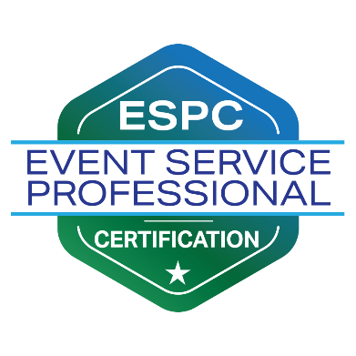
Foundational Training Waiver Request
Complete Request form and return to Event Service Professionals Association Headquarters along with your ESPC Application at certification@espaonline.org

Name:

Company:

Email Address:

Signature:

Date:

(The above information is for ESPA Headquarters processing only. Name will be removed prior to submitting to the ESPA Review Board so that the evaluation is based on merit only.)

(Internal Waiver Request code:_____)

Continued on page two.

(Internal Waiver Request code:_____)

Professional History

- Number of years of experience in the event service industry:
*10-years of experience in event service positions is required.

- List your industry experience which represent the minimum 10 years.
Company:
Title(s) (Include all titles if your position changed during the period)
Dates of employment:

Company:
Title(s) (Include all titles if your position changed during the period)
Dates of employment:

Company:
Title(s) (Include all titles if your position changed during the period)
Dates of employment:

- In which industry category do you have professional work experience (i.e. through actual employment)? (Check all that apply)

□ Convention Center
□ Hotel
□ CVB/DMO
□ Attraction/ Special Event/Venue
□ Other: _______________________

- For the categories listed in question 3 that you do not have direct employment experience,
please provide detailed event servicing contributions and involvement within those other industry verticals. What specific event services do you provide those partners and how do those services complement each other? How did you contribute to the success of events in relation to the areas you don’t have direct employment experience? How did your involvement help to inform you about event services in those areas? Your answer will need to include enough detail to sufficiently demonstrate your knowledge of all areas to the ESPA Review Board.

Please write or paste your responses in below:

- Have you earned any of the following industry certifications? (Check all that apply)

□ CMP: Certified Meeting Professional
Earned/Recertified on: _____________
□ CSEP: Certified Special Event Professional
Earned/Recertified on: _____________
□ CPCE: Certified Professional in Catering and Events
Earned/Recertified on: _____________
□ CGMP: Certified Government Meeting Professional
Earned/Recertified on: _____________
□ CMM: Certification in Meeting Management
Earned/Recertified on: _____________

□ CEM: Certified in Exhibition Management
Earned/Recertified on: _____________
□ CVP: Certified Venue Professional
Earned/Recertified on: _____________
□ DMCP: Destination Management Certified Professional
Earned/Recertified on: _____________
□ STS: Sports Tourism Strategist
Earned/Recertified on: _____________
□ Other: __________________________
Valid Until: _____________________
□ Other: __________________________
Valid Until: ____________________

