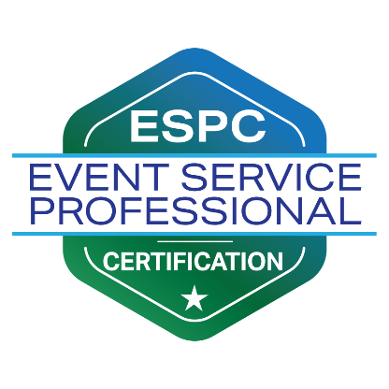

Event Service Professional Certification
Capstone Project Form: The Challenge

Complete form and return to Event Service Professionals Association Headquarters at certification@espaonline.org
Certification fee must be paid prior to form being processed and review being conducted.

Instructions:
Candidates must first submit the challenge for review and approval by the ESPA Review Board before proceeding to the written response. Candidates have the option to submit their Challenge at the same time as their application to expedite the review process. Please allow 21 days for response on challenge reviews.

Candidates have up to one year to complete their Capstone Project once their application has been approved. After one year, a new application and fee must be submitted.

Form must be typed, not hand-written.

Name: _____________________________________________________________________________

Title: _______________________________________________________________________________

Company: ___________________________________________________________________________

Email Address: ______________________________ Office Phone: __________________________

Date Certification (Capstone Project) Fee was paid: ____________

Part 1: Write and Submit an Event Service Challenge

Develop and describe a hypothetical, or reference a real-world, challenge scenario within one of the subject matter areas listed below. Be sure to include detailed context about the challenge:

- What is the overall impact of the challenge?
- How does the challenge impact the CVB, venue, attraction?
- Who is impacted by the challenge? The group, employees, visitors, others?
- What caused the challenge?

Challenge Areas:

- Connecting Events to the Local Business Economy (Intellectual Capital)
- Corporate Social Responsibility and Giving Back to the Community
- Sustainability
- Customer Service
- Emerging Trends in Event Services
- Event Design
- Technology
- Food & Beverage
- Risk management / Health & Safety
- Measuring Event Success
- Promoting and Marketing Your Destination or Venue
- Servicing by Market Segment

Indicate your selected Challenge Area from the above list: ____________

Type or paste your Challenge below, above signature line (use as much space as necessary):

Signature: ____________________________________________________________________________

Date: ___________________

Complete form and return to Event Service Professionals Association Headquarters at certification@espaonline.org
Certification fee must be paid prior to form being processed and review being conducted.

